AI Assisted Assignment 15.4
Name:Kanneboyina Meghana
HTNO: 2303A52345
Batch 44
Task 1:
Prompt:
Generate a basic Flask application with a /status endpoint that returns JSON {"status": "API is running"}.
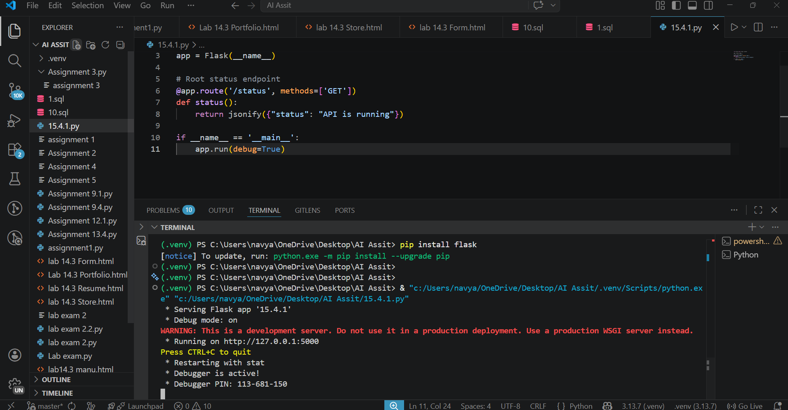
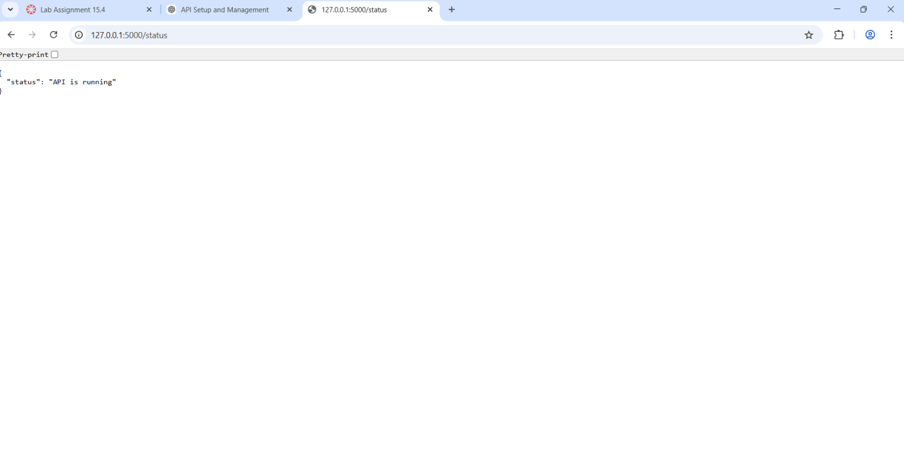
Observation:
- Flask server started successfully.
- Accessing /status returned:
{"status": "API is running"}
- Confirms backend is working.
Task 2:
Prompt: Create GET and POST endpoints in Flask to store service requests in memory. Each request has title and priority.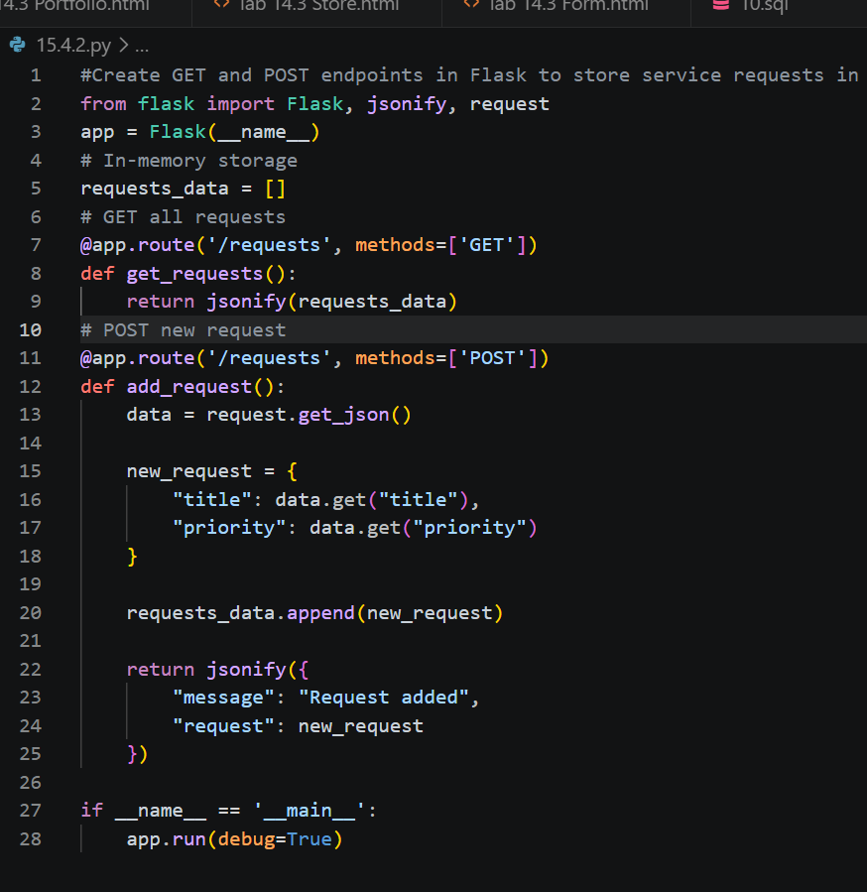
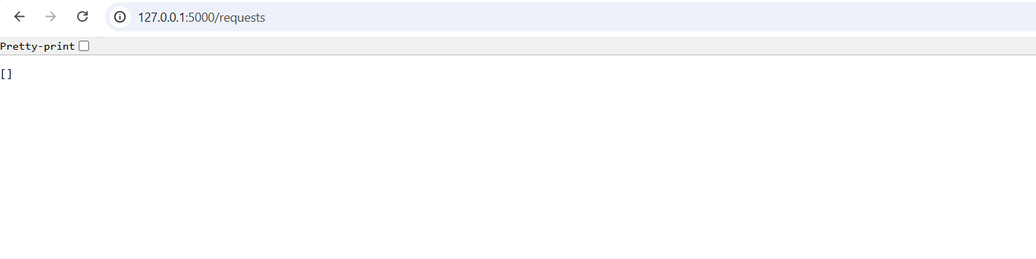
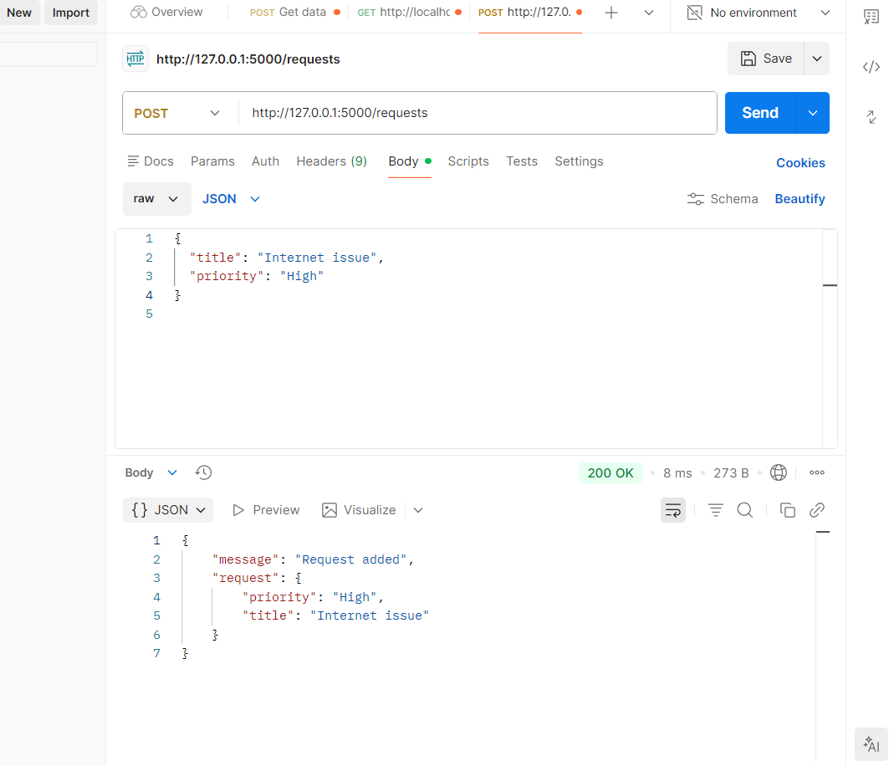
Observation :
- Initially GET returned empty list
- POST successfully added request
- Data stored temporarily in memory
- Subsequent GET returned added data
Task 3:
Prompt: Add a PUT endpoint to update a service request by index with proper error handling.
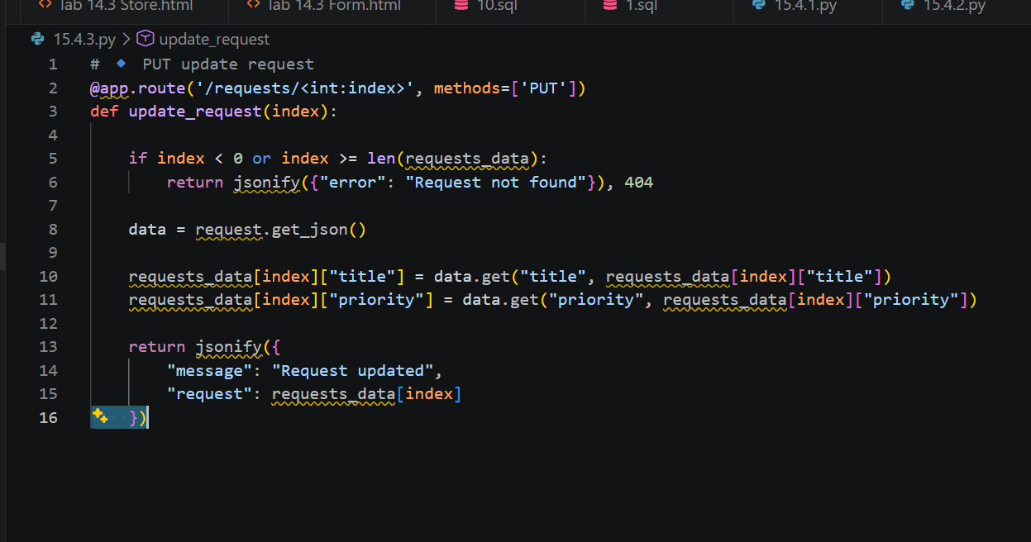

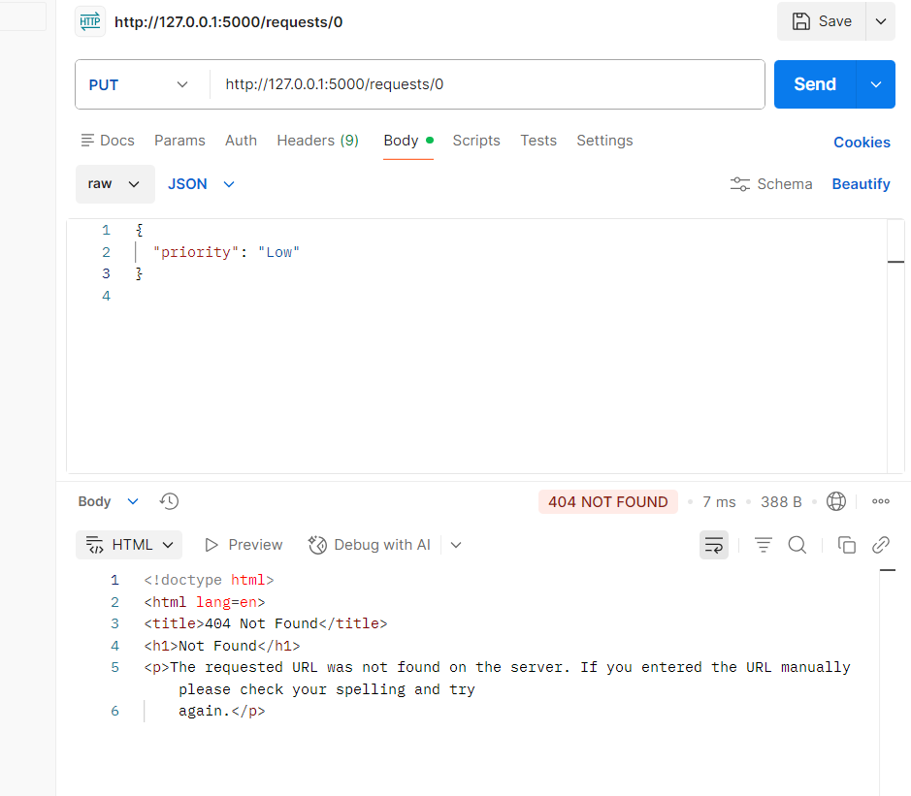
🔹 📝 Observation
- Valid index updated successfully
- Returned updated object
- Invalid index returned:
{"error": "Request not found"}
- HTTP status: 404
Task 4:
Prompt:
Create a DELETE endpoint to remove a request by index and return deleted data.
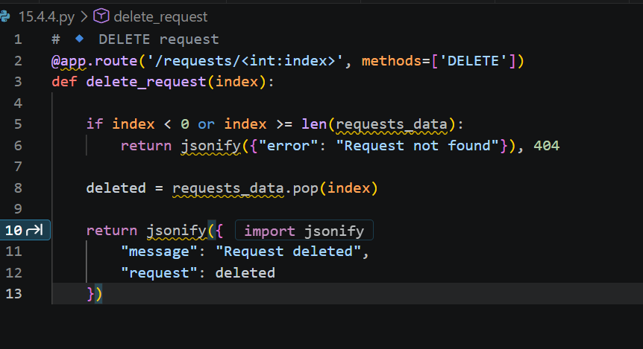

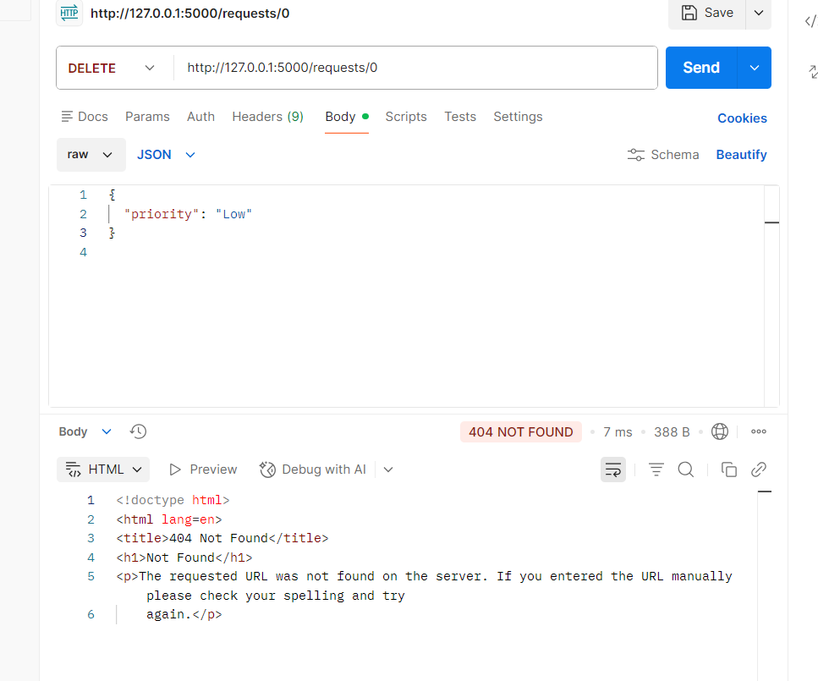
Observation
- Request removed successfully
- Deleted data returned
- Invalid index handled safely
- Server did not crash
Task 5:
Prompt:
Add docstrings and comments to Flask API endpoints for better readability and documentation.

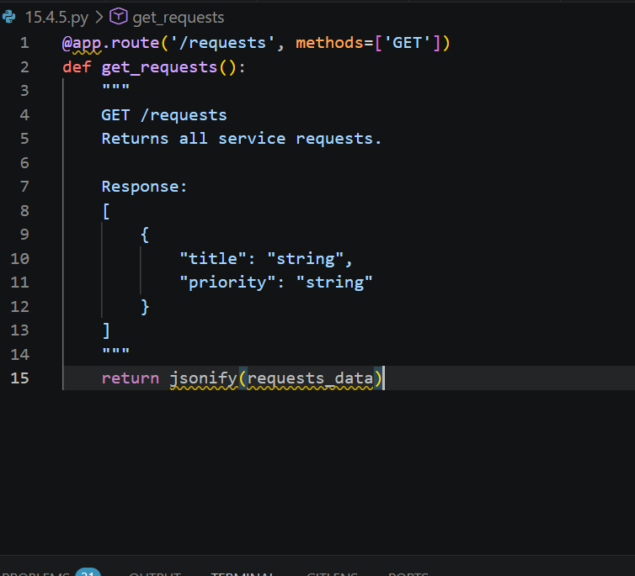

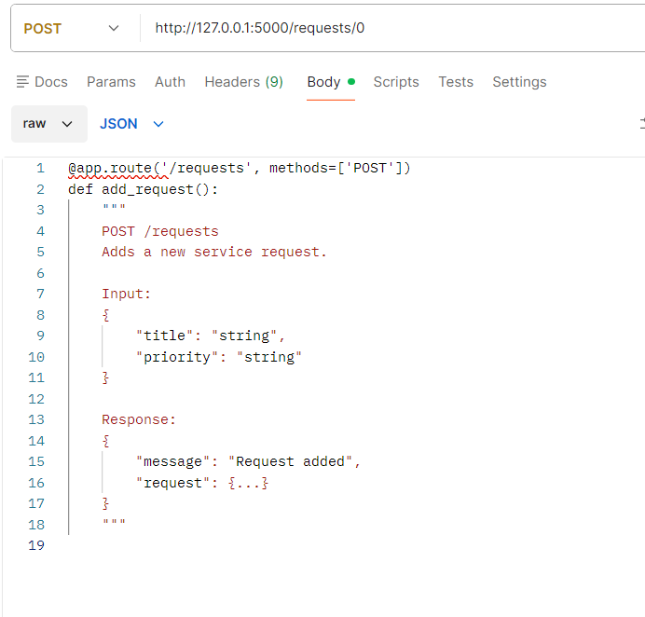
Observation
- Added docstrings for all endpoints
- Improved readability
- API easy for other developers to understand
- Swagger UI (optional) provides interactive documentation

